SE Lab 2
SRN:PES1UG24AM217
Date:01/09/2026
Name: Rahul Prasanna
Backlog List:
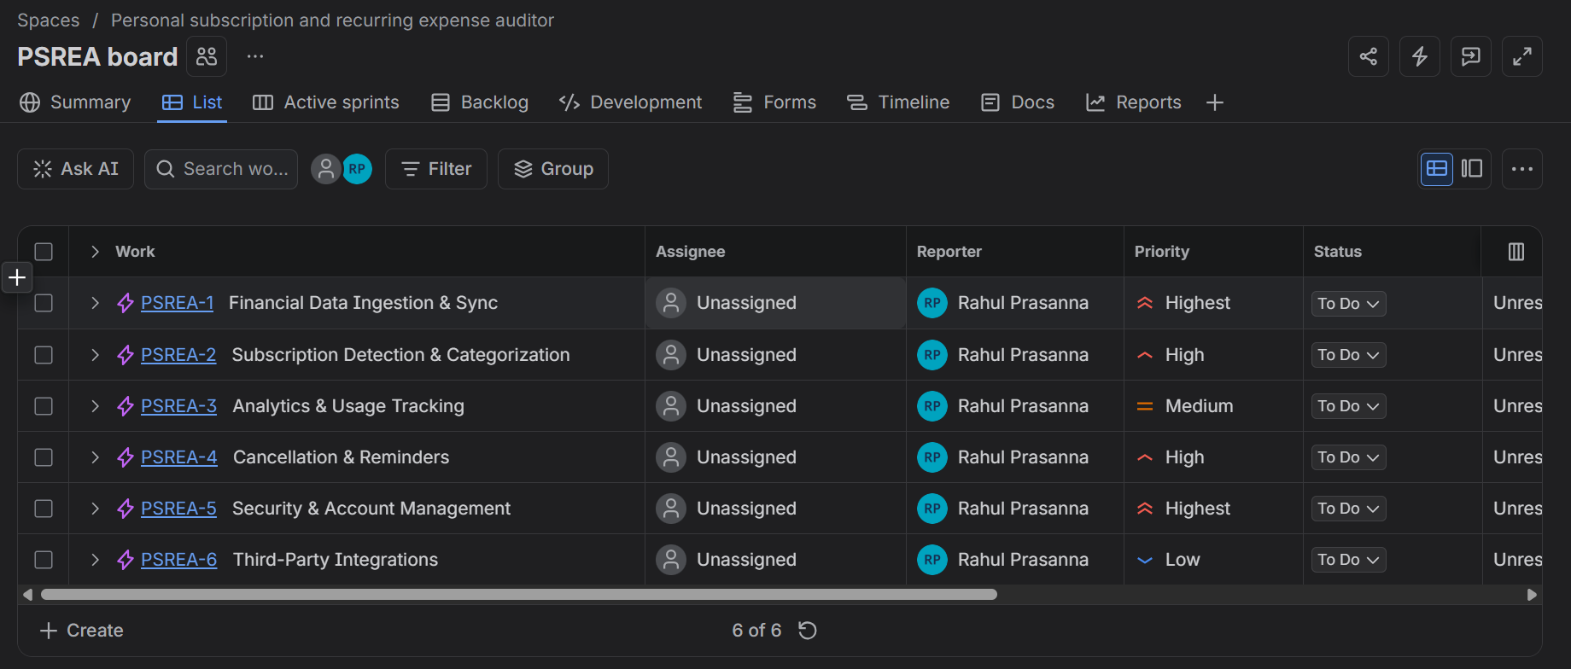
1.1) 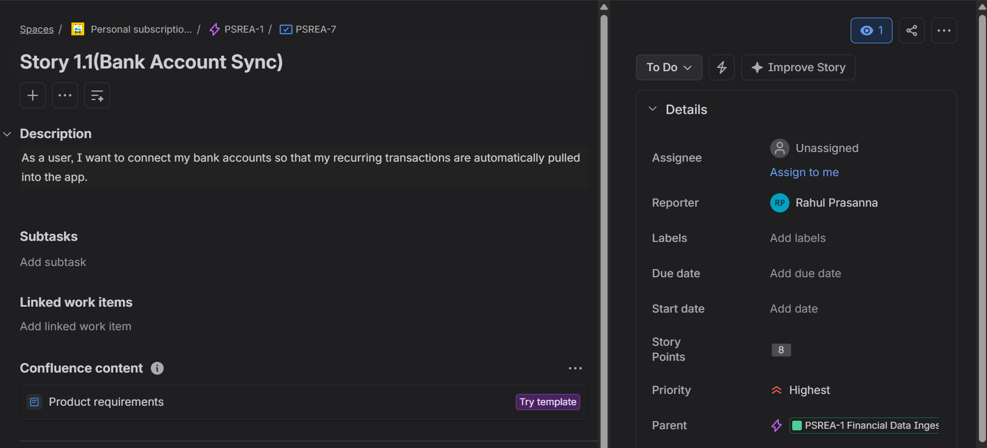

1.2) 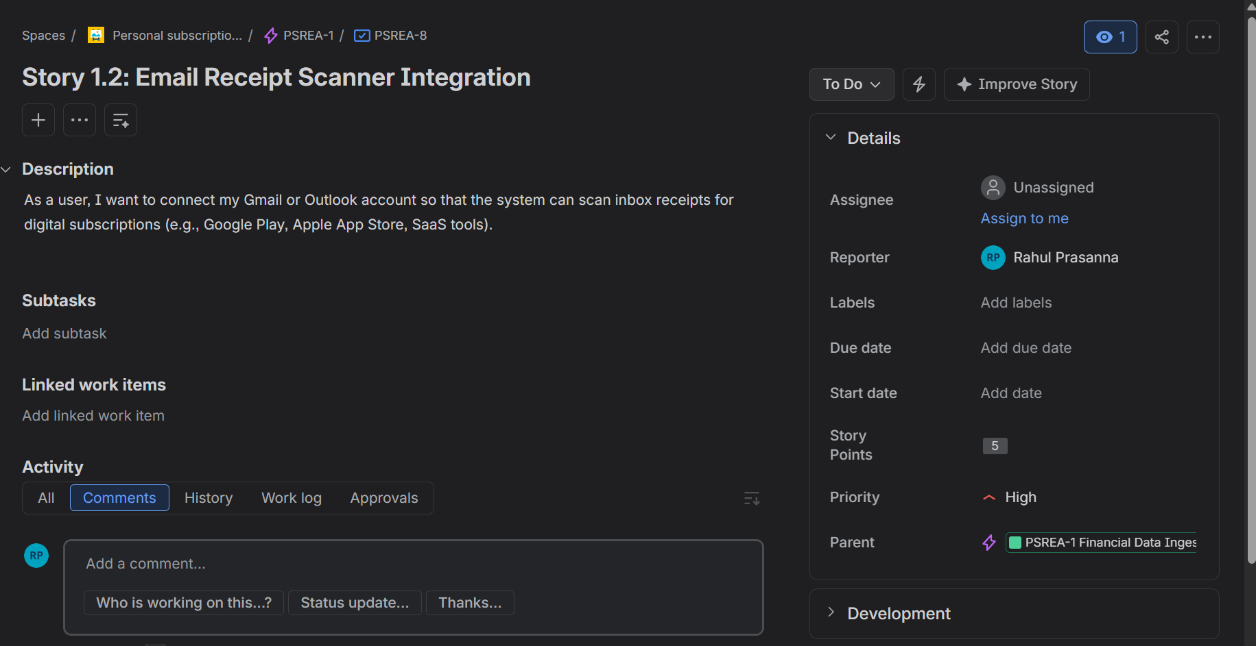
2.1)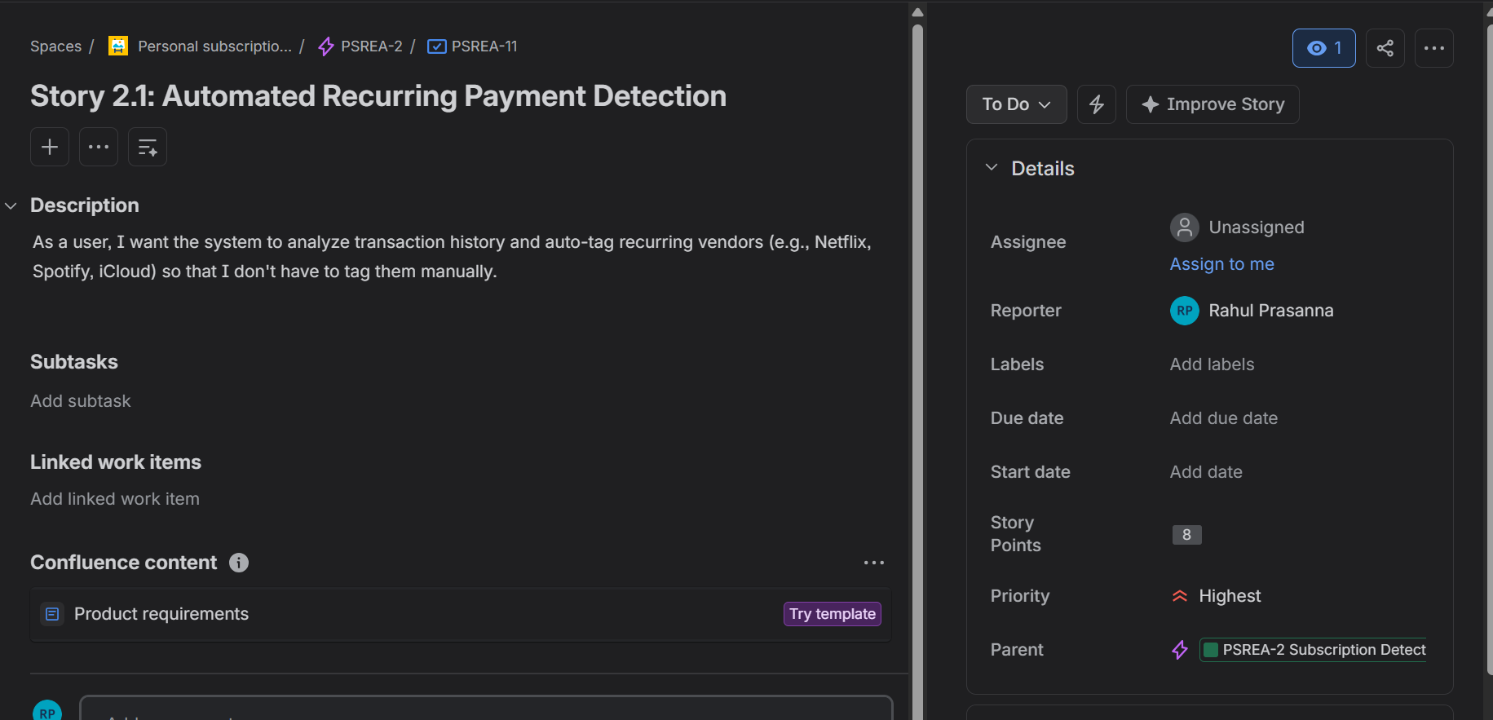
2.2)
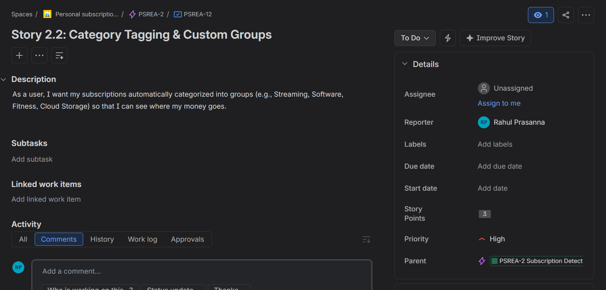
3.1) 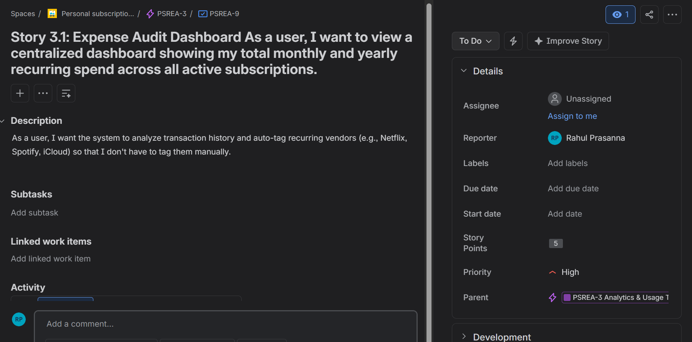
3.2) 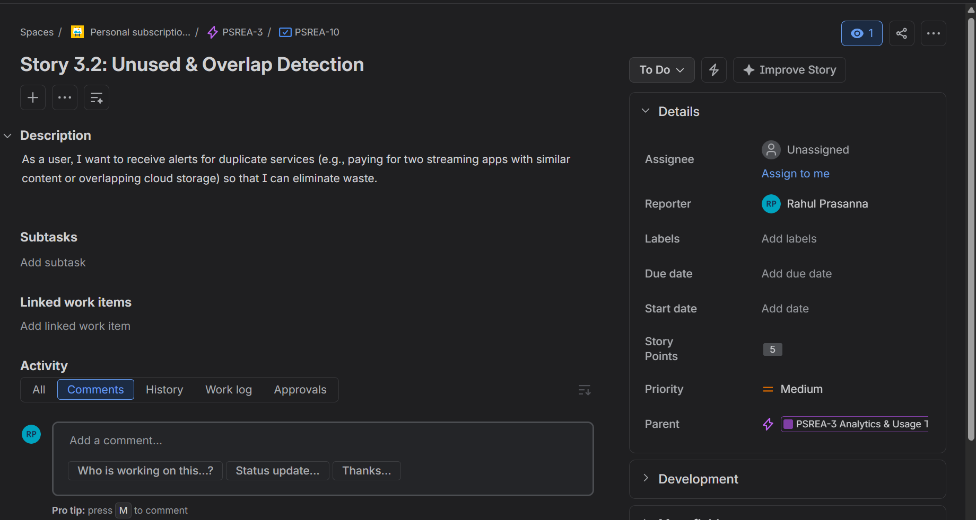
4.1) 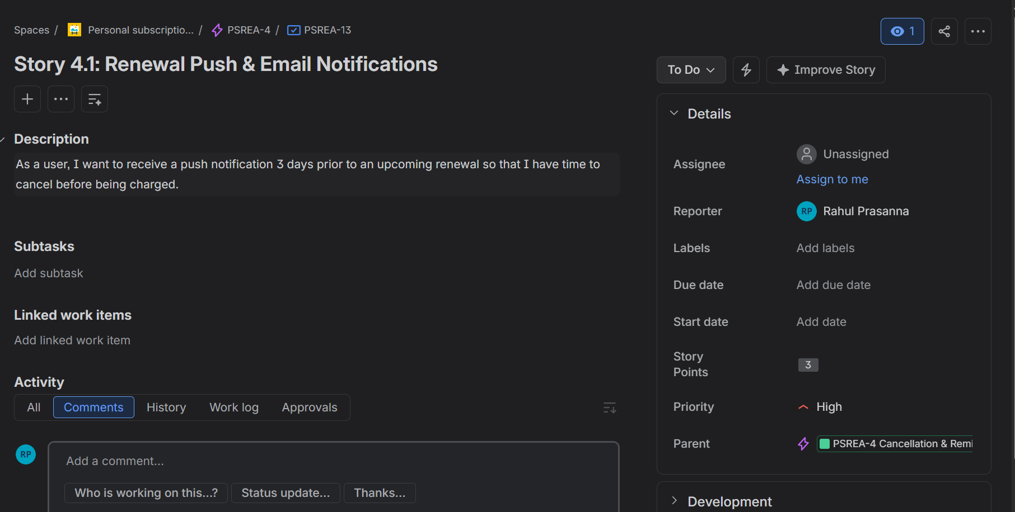
4.2) 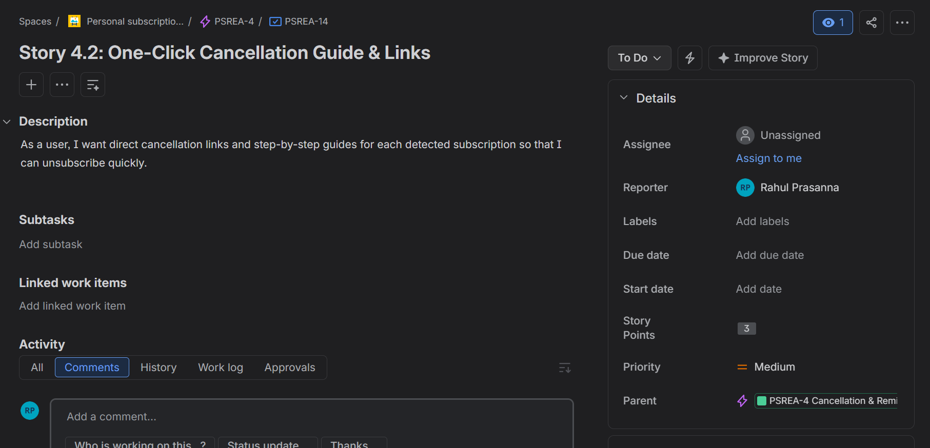
5.1) 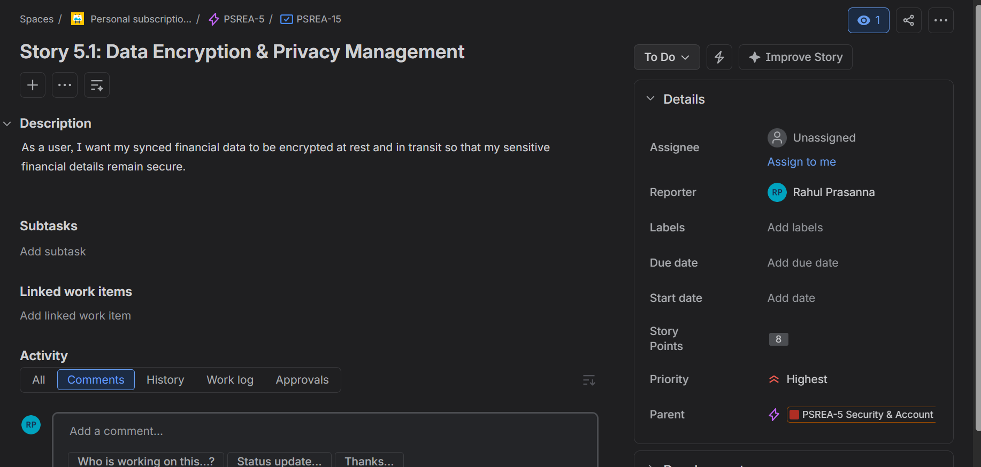
5.2)
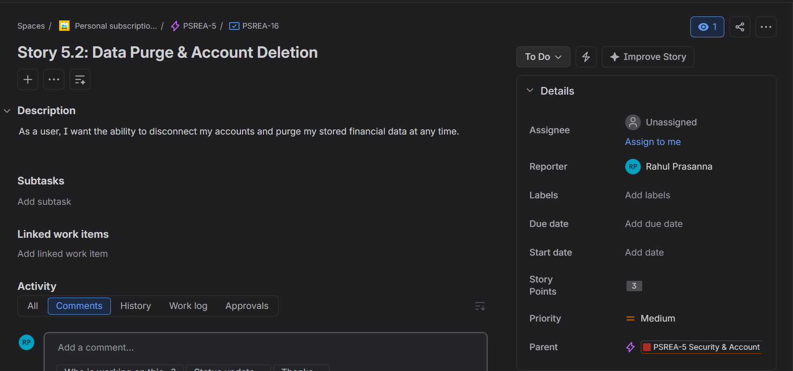
6.1) 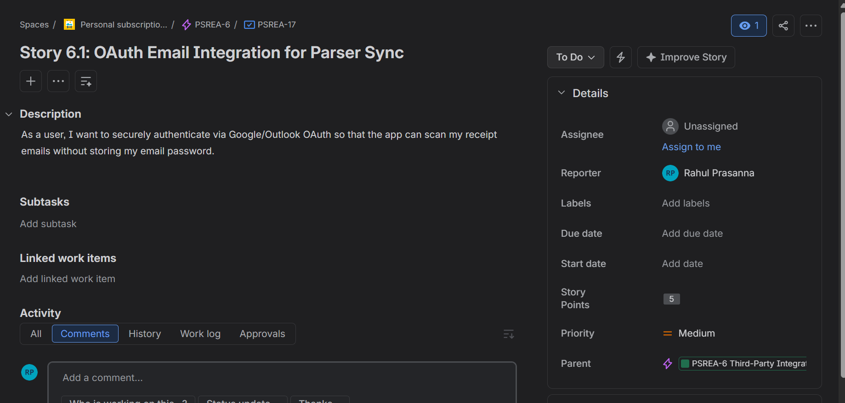
6.2)

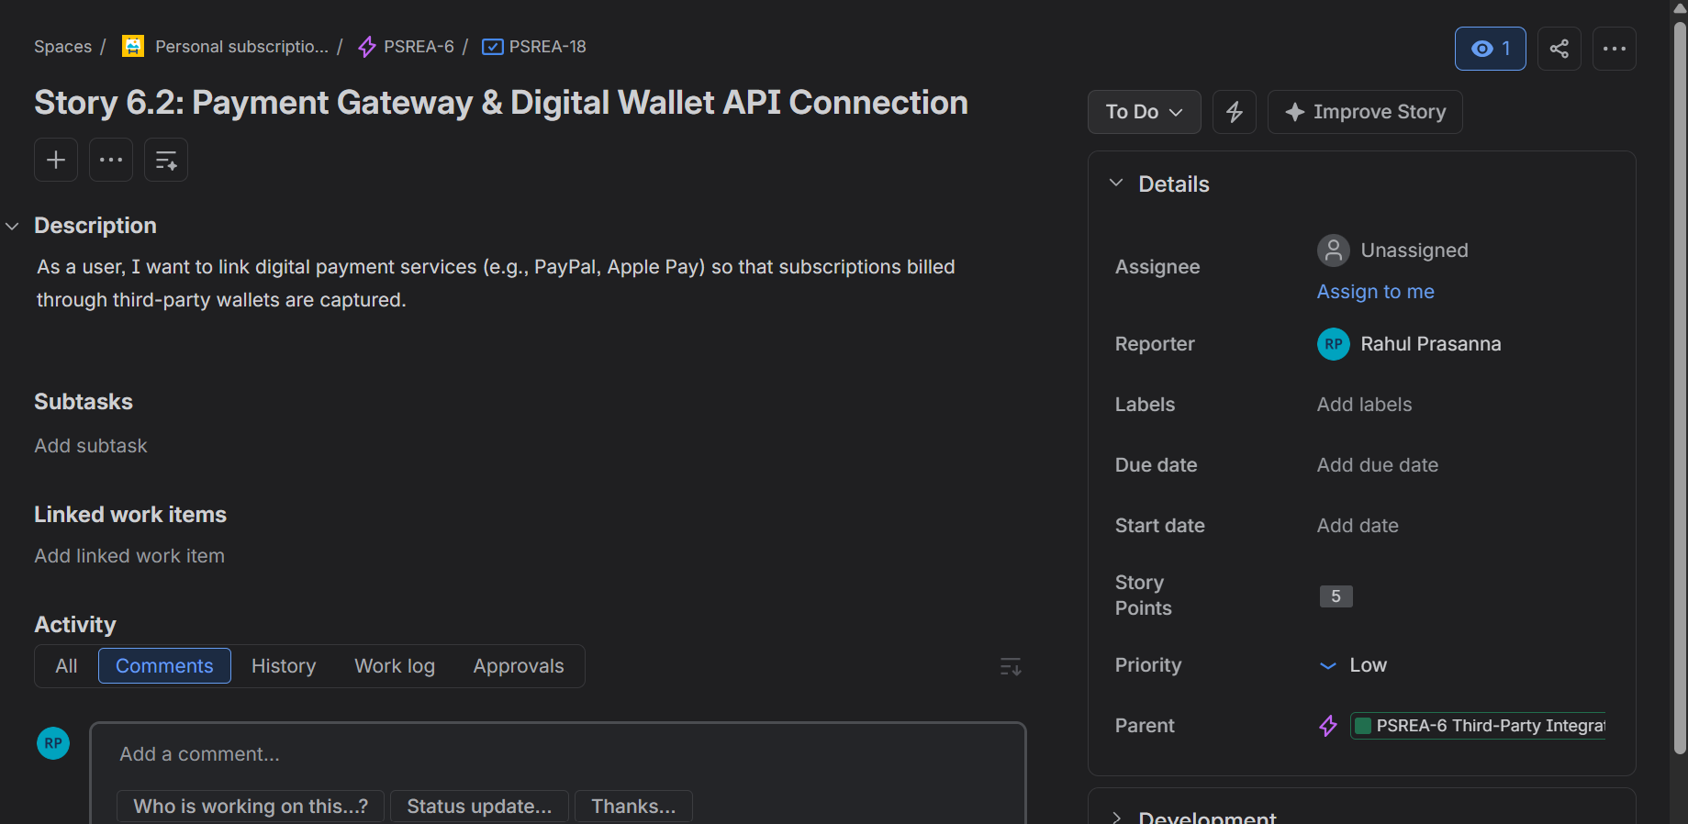
Sprint 1 outputs:
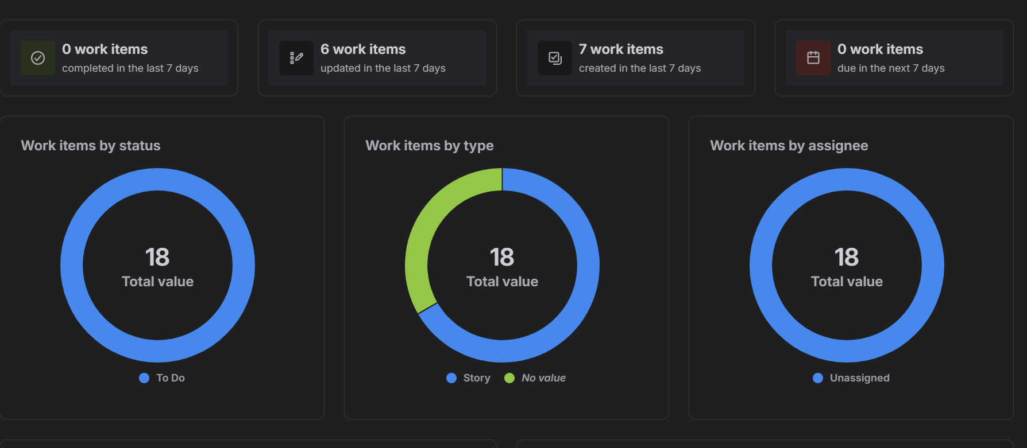
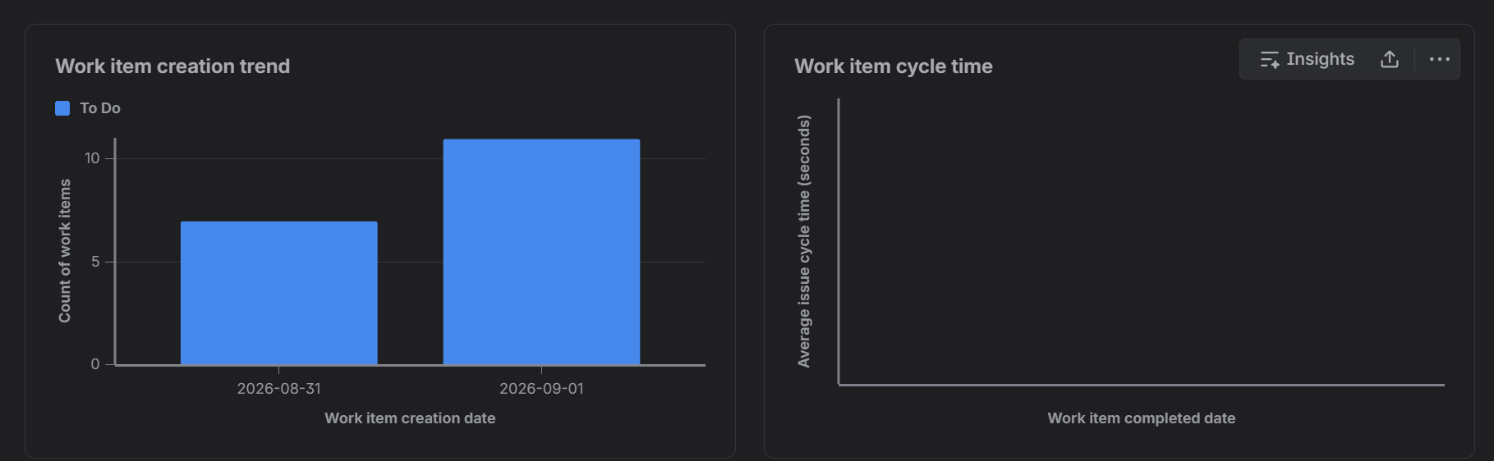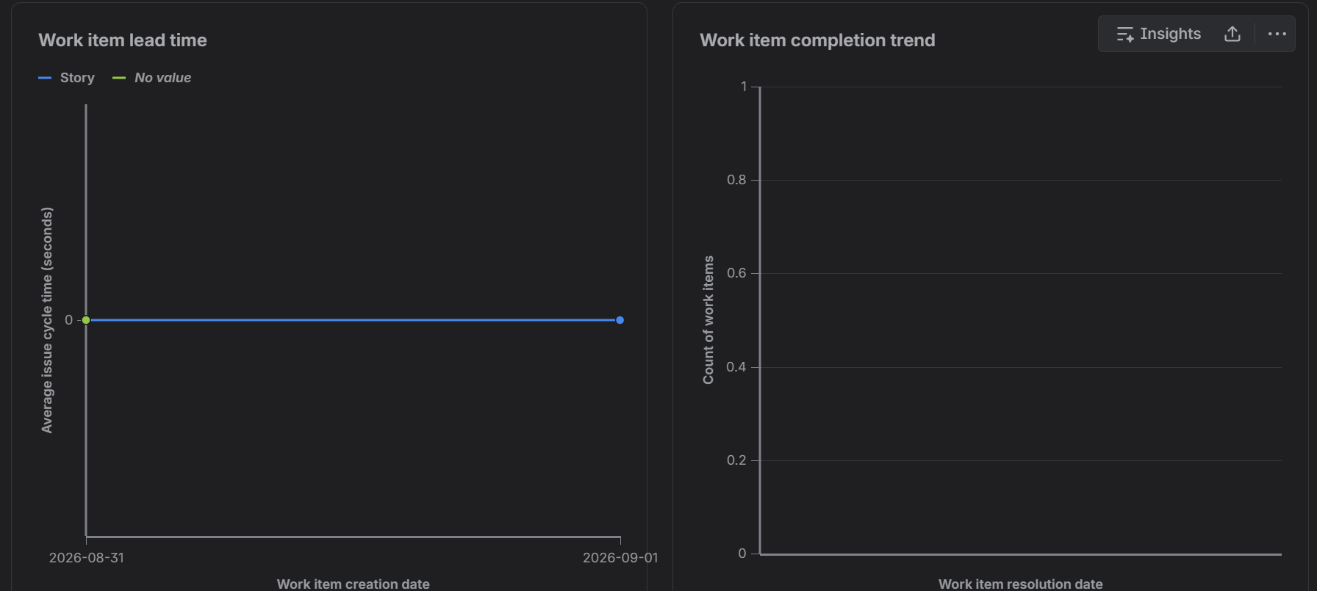
Sprint 2:
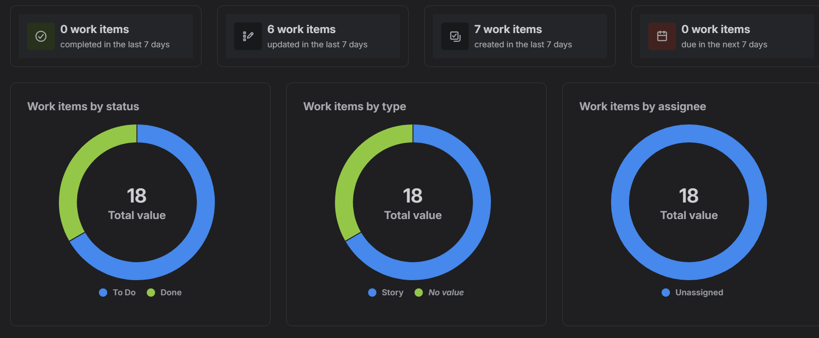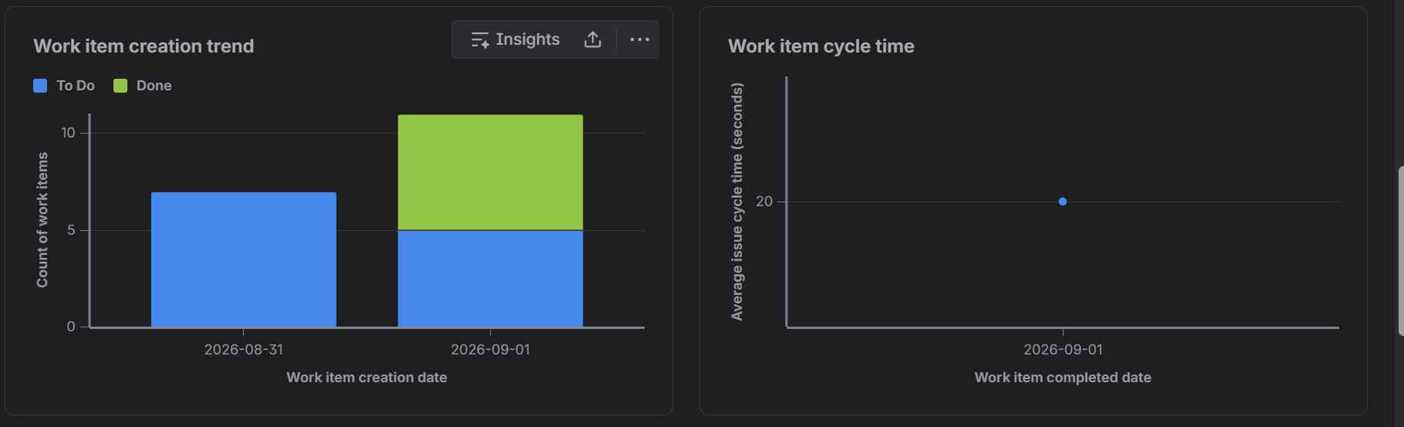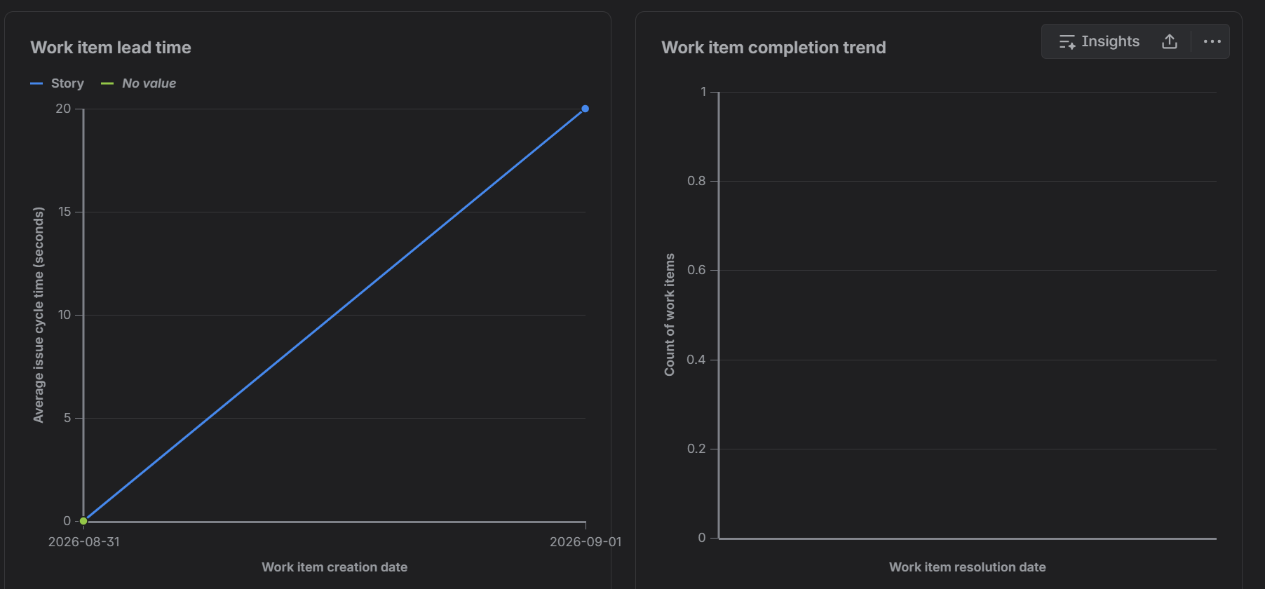
Summary:
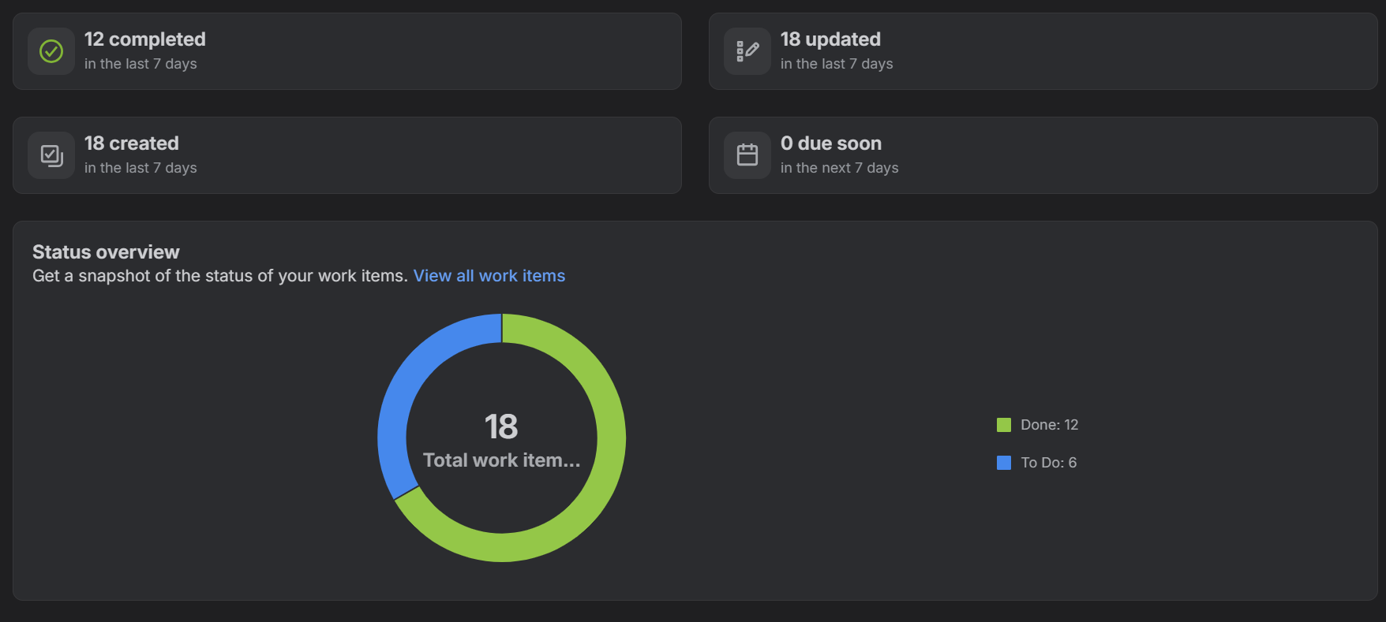
Sprint Reflection:
Performance in Sprint 1: Sprint 1 is the backlog setting and planning sprint. According to the metric dashboard, there are 18 total work items (6 Epics, 12 User Stories) added during August 31-September 1, 2026. According to the initial “Work items by status” donut chart, 100% of work items are in “To Do” with an average issue cycle time of 0 seconds meaning that all tasks of Sprint 1 were devoted to the story point estimation and linking with epics.
Sprint 2 Progress: In Sprint 2, the active execution started. The “Work item creation trend” and “Work items by status” diagrams show that 6 work items have been successfully completed in “Done” with the average cycle time and lead time of 20 seconds each. Key stories for the main features (detection of MVPs, renewals, and encryption) have been executed providing the operational velocity of the project.
Key Points for Next Sprint: Assign specific team members to unassigned issues; define subtasks within the high point stories (Story 1.1 and Story 2.1); provide steady daily work rate avoiding completing all tasks in one day.
Group Reflection
Alignment of Agile Framework: Diving into the complicated domain of financial expense auditor in 6 well-structured Epics enabled us to decouple the concerns into ingestion and payments (Epics 1&2) from security and integrations (Epics 5&6).
Insights from Estimations and Prioritization: Applying the Fibonacci sequence (1,2,3,5,8) in estimation made it clear what story is more complex and risky (8-point stories like Bank Account Sync and Encryption) compared to the simple one (3-point Renewal Notifications). Prioritization made sure that infrastructure elements would be in early sprints rather than additional features such as third-party wallet integration.
Lessons Learned: It was shown how important dashboard reports in Jira are for the project progress. Lead times, status distribution chart, and epics bars give an idea of bottleneck parts of the project and its progress.
Burndown Chart:
Sprint 1:
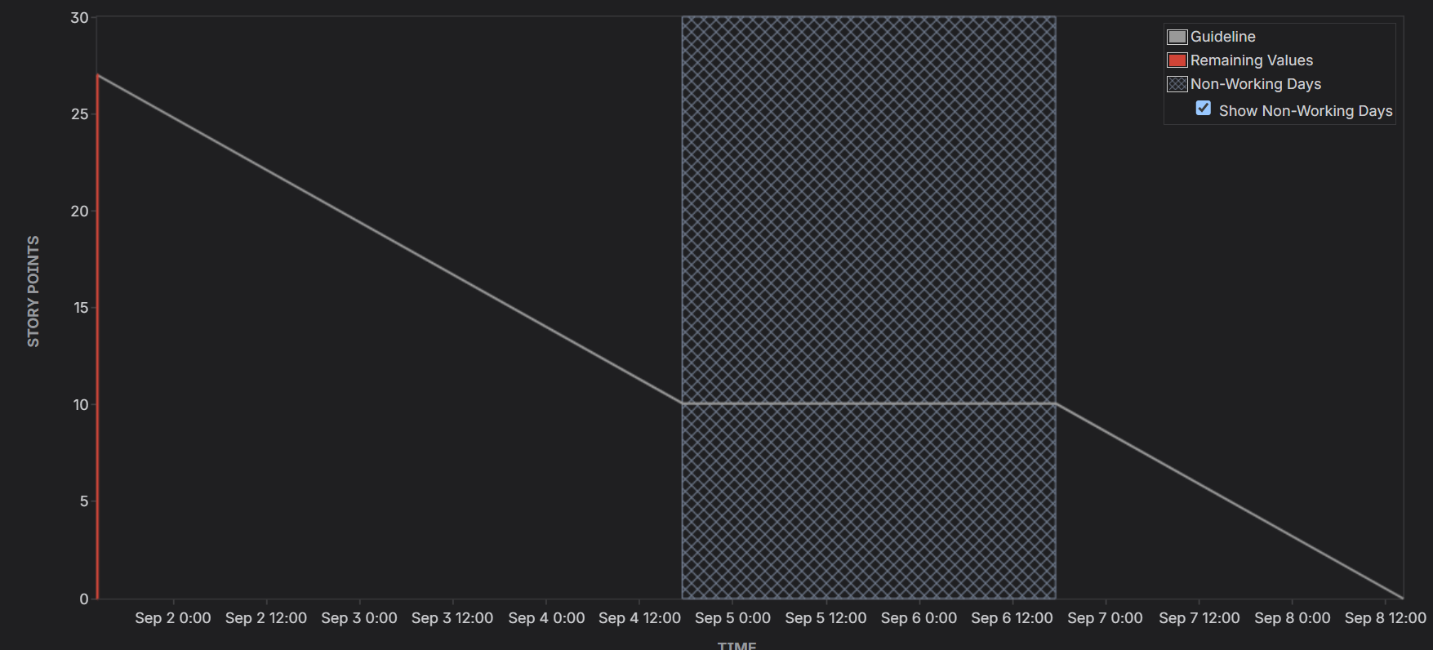
Sprint 2:
